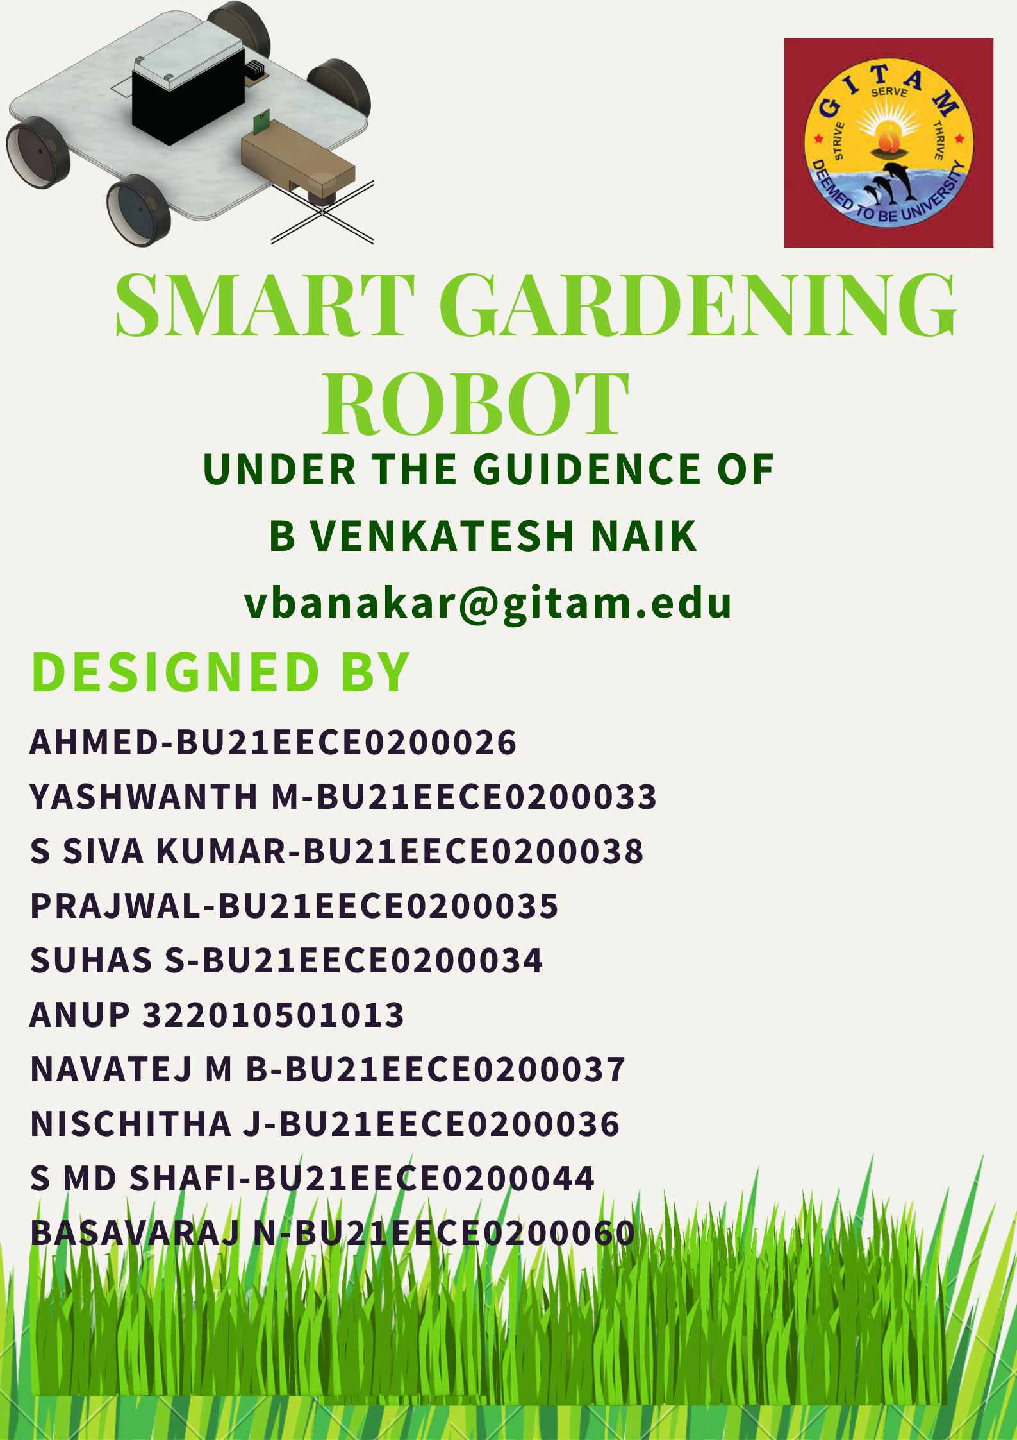

OBJECTIVES: -

1. To reduce the size of Machines.
2. To reduce the man power and making it as semi-operative machine.
3. To find out the problems facing in electric or battery-operated machines in practically.

***SMART GARDNENING ROBOT COMPONENTS***

1. Wooden Sheet
2. L298N Motor Driver Controller
3. 12v DC Gear Motor
4. 12v 7Ah Lead Acid Battery
5. ESP8266
6. ESP32 Cam Module
7. 2200kv BLDC Motor and Controller
8. BLDC Servo Controller

**Wooden Sheet: -**



The dimensions of sheet are as follows,

40 CM



37 CM



6 MM



We have used Plywood for base because to reduce weight and increase the holding capacity.

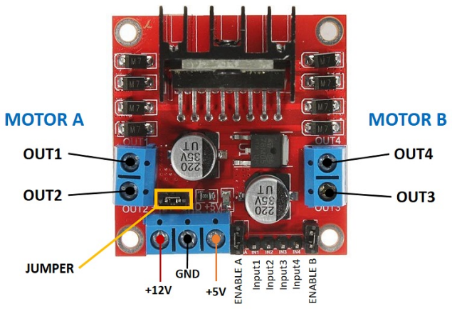

**L298N Motor driver: -**

|  |  |
| --- | --- |
| Motor output voltage | 5V – 35V |
| Motor output voltage (Recommended) | 7V – 12V |
| Logic input voltage | 5V – 7V |
| Continuous current per channel | 2A |
| Max Power Dissipation | 25W |

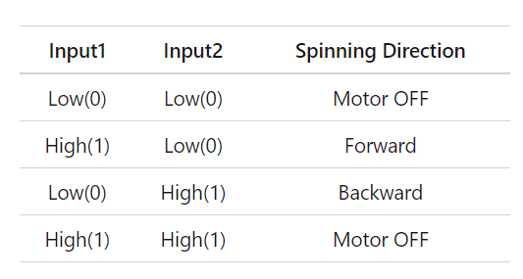Technical Specifications

Instead of this L298N motor driver we can use individual PWM controller for each motor if motor current rating is more that 3A. We have chosen this driver because of its rating and easy to controller using external microcontroller.

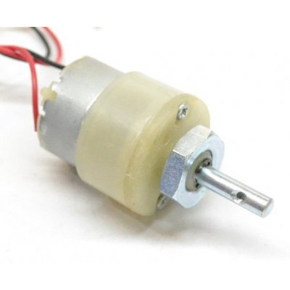**DC Gear Motor: -**

**Specifications and Features: -**

* RPM: 100.
* Operating Voltage: 12V DC
* Gearbox: Attached Plastic (spur)Gearbox
* 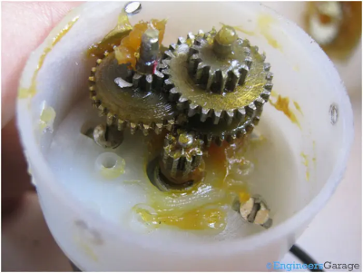Shaft diameter: 6mm with internal hole
* Torque: 2 kg-cm
* No-load current = 60mA (Max)
* Load current = 300mA (Max).

We have chosen this Metal gear motor instead of BO gear motor because the weight of this grass cutter robot is high due to the battery and some other components. If the weight is less, you can use BO gear motors for cost reduction and less weight.

Gear motors characteristics:

|  |  |  |
| --- | --- | --- |
| Voltage | Speed | Current |
| 5 V | 42 RPM | 0.2 A |
| 6 V | 54 RPM | 0.2 A |
| 7 V | 66 RPM | 0.2 A |
| 8 V | 75 RPM | 0.2 A |
| 9 V | 85 RPM | 0.2 A |
| 10 V | 96 RPM | 0.2 A |
| 11 V | 105 RPM | 0.3 A |
| 12 V | 115 RPM | 0.3 A |

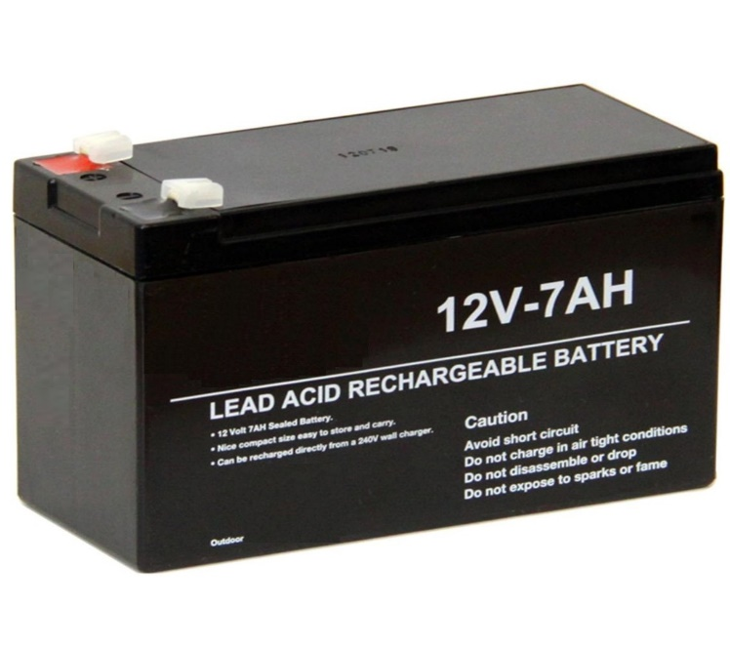**Battery: -**

Specifications

Voltage: - 12v

Charge Current: - 2.16A

Discharge Current: - 100A

Dimensions: - 151*65*95 cm

Weight: - 2500g

We have chosen this lead acid battery due to its voltage and current specifications. We can use Li-ion Batteries instead of Lead acid battery but the cost is more and we need to give external protection compared to lead acid battery. The main reason of choosing this lead acid battery is to reduce cost and complexity.

**ESP8266 NodeMCU: -**

ESP8266Specifications & Features

* Microcontroller: Tensilica 32-bit RISC CPU Xtensa LX106
* 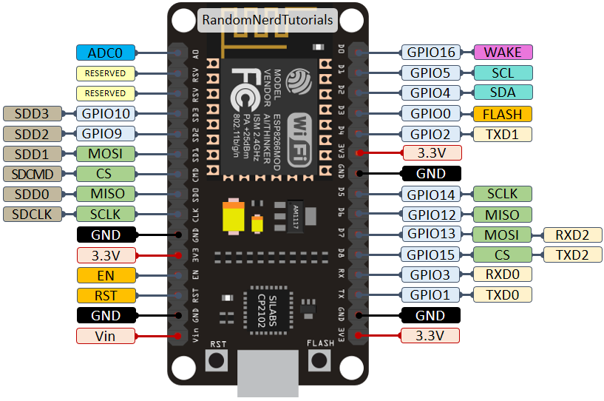Operating Voltage: 3.3V
* Input Voltage: 7-12V
* Digital I/O Pins (DIO): 16
* Analog Input Pins (ADC): 1
* UARTs: 1
* SPIs: 1
* I2Cs: 1
* Flash Memory: 4 MB
* SRAM: 64 KB
* Clock Speed: 80 MHz
* USB-TTL based on CP2102 is included onboard, Enabling Plug n Play
* PCB Antenna
* Small Sized module to fit smartly inside your IoT projects

The reason that we chose this NodeMCU instead of Arduino UNO or ESP32 NodeMCU is to reduce cost and complexity. As per our calculations, this ESP8266 is enough to control the grass cutter. If you are designing any kind of robot with more features, you may go with ESP32 or Arduino Mega.

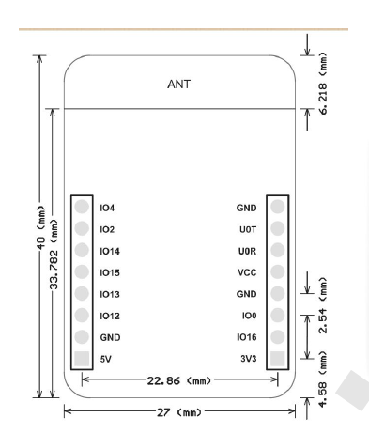

**ESP32 Cam Module**

Specifications

* WIFI module: ESP-32S
  + Processor: ESP32-D0WD
* Built-in Flash: 32Mbit
* RAM: Internal 512KB + External 4M PSRAM
* Antenna: Onboard PCB antenna
* WiFi protocol: IEEE 802.11 b/g/n/e/i
* Bluetooth: Bluetooth 4.2 BR/EDR and BLE
* WIFI mode: Station / SoftAP / SoftAP+Station
* Security: WPA/WPA2/WPA2-Enterprise/WPS
* Output image format: JPEG (OV2640 support only), BMP, GRAYSCALE
* Supported TF card: up to 4G
* 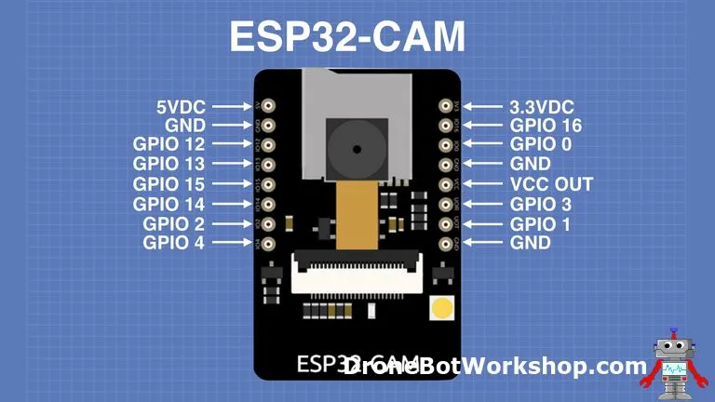Peripheral interface: UART/SPI/I2C/PWM
* IO port: 9
* UART baud rate: default 115200bps
* Power supply: 5V
* Transmitting power:
  + 802.11b: 17 ±2dBm (@11Mbps)
  + 802.11g: 14 ±2dBm (@54Mbps)
  + 802.11n: 13 ±2dBm (@HT20, MCS7)
* Reception sensitivity:
  + CCK,1Mbps: -90 dBm
  + CCK,11Mbps: -85 dBm
  + 6 Mbps (1/2 BPSK): -88 dBm
  + 54Mbps (3/4 64-QAM): -70 dBm
  + HT20, MCS7(65Mbps, 72.2Mbps): -67 dBm
* Power consumption:
  + Flash off: 180mA@5V
  + Flash on and brightness max: 310mA@5V
  + Deep-Sleep: as low as 6mA@5V
  + Modern-Sleep: as low as 20mA@5V
  + Light-Sleep: as low as 6.7mA@5V
* Operating temperature: -20 ℃ ~ 85 ℃
* Storage environment: -40 ℃ ~ 90 ℃, <90%RH
* Dimensions: 40.5mm x 27mm x 4.5mm

The reason why we are using ESP32 cap module is to see the view of the grass cutting robot and when we are operating from long distance, we can’t go to near the robot to see weather it is cutting grass or not. That’s why we included this camera to see what’s happening there.

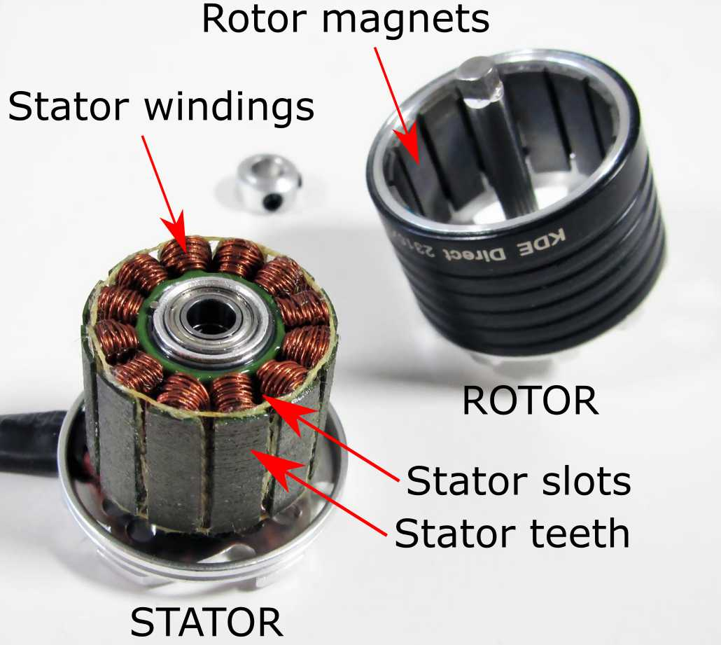**BLDC Motor and Controller**

**Specifications of BLDC Motor: -**

* KV: 2200 kV
* No load Current: 10 V: 0.5 A.
* Current Capacity: 12A/60s
* No Load Current @ 10V: 0.5A
* 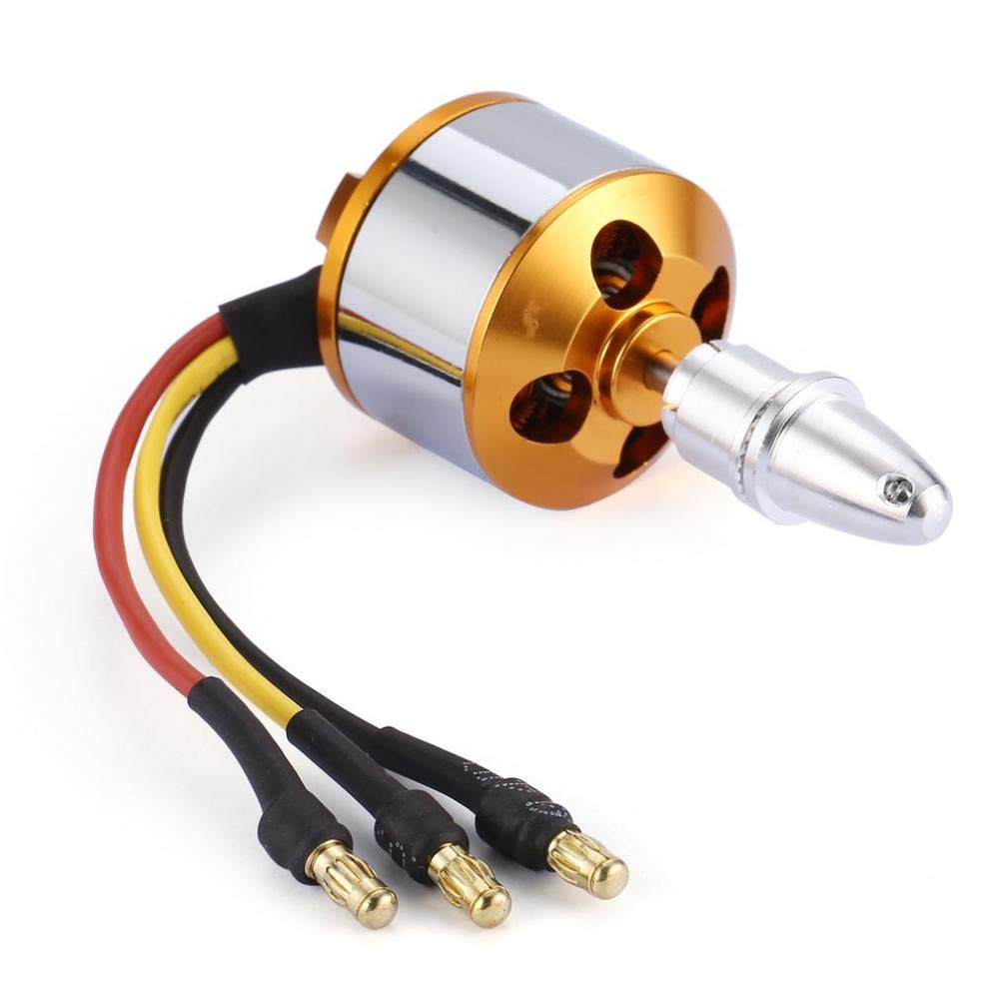No. Of Cells: 2-3 Li-Poly
* Motor Dimensions: 27.5 x 30mm
* Shaft Diameter: 934;3.17mm
* Shaft diameter: 3.175mm.
* Minimum ESC Specification: 18A (30A Suggested)
* Thrust @ 3S with 1045 propeller: 1200 gms approx.
* Thrust @ 3S with 0945 propeller: 750 gms approx.
* Thrust @ 3S with 0845 propeller: 650 gms approx.

**Specifications and Features of ECS Controller: -**

* MODEL: STANDARD 30A BLDC ESC ELECTRONIC SPEED CONTROLLER
* 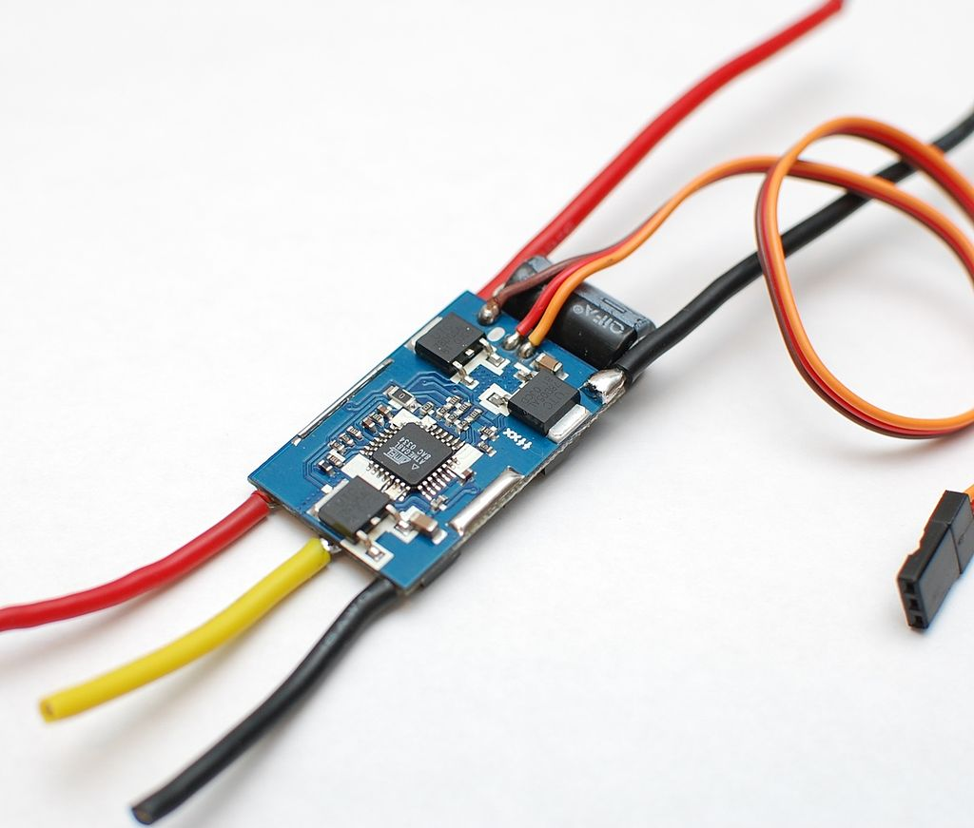WEIGHT: 23g
* DIMENSIONS: 45 x 24 x 9 mm (LxWxH)
* Colour: Yellow/Red (Depends on Availability)
* CURRENT (A): 30A
* BEC: 3A
* Li-Poly: 2-3
* Ni-Mh/Ni-CD: 4-10 Ni-Mh
* CONSTANT CURRENT: 30A Max 40A<10s
* Li-Poly 2-3 CELLS; Ni-MH 4-10 CELLS Auto Detect
* Break On/Off
* Auto Low BATTERY Slow down at 3.0V/cell Lipo, cut-off at 2.9V/cell lipo
* APPLICATION: Multirotor, RC Airplanes, etc.

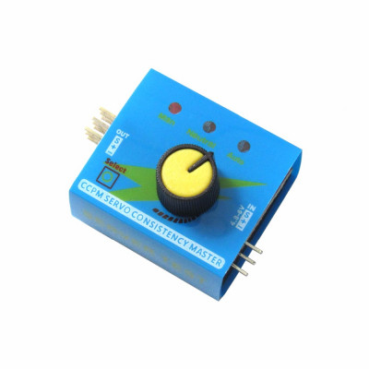

**BLDC MOTOR SERVO CONTROLLER**

* Operating Voltage: DC 4.8-6V
* Offer 3 modes to check servos or ESC
* The Manual Mode allows you to turn the knob to different speeds and check the reaction time
* The Neutral mode makes the servo go back to the neutral point
* The Automatic “Window Wiper’’ Mode makes the servo swing like a window wiper in the largest angle possible
* Connect to up to 3 servos simultaneously
* Connect up to 3 ESCs to test and compare their reaction time respectively
* Built with LED indicators
* Output signal: 1.5ms±0.5ms
* Size: 36.5 x 31.0 x 22mm

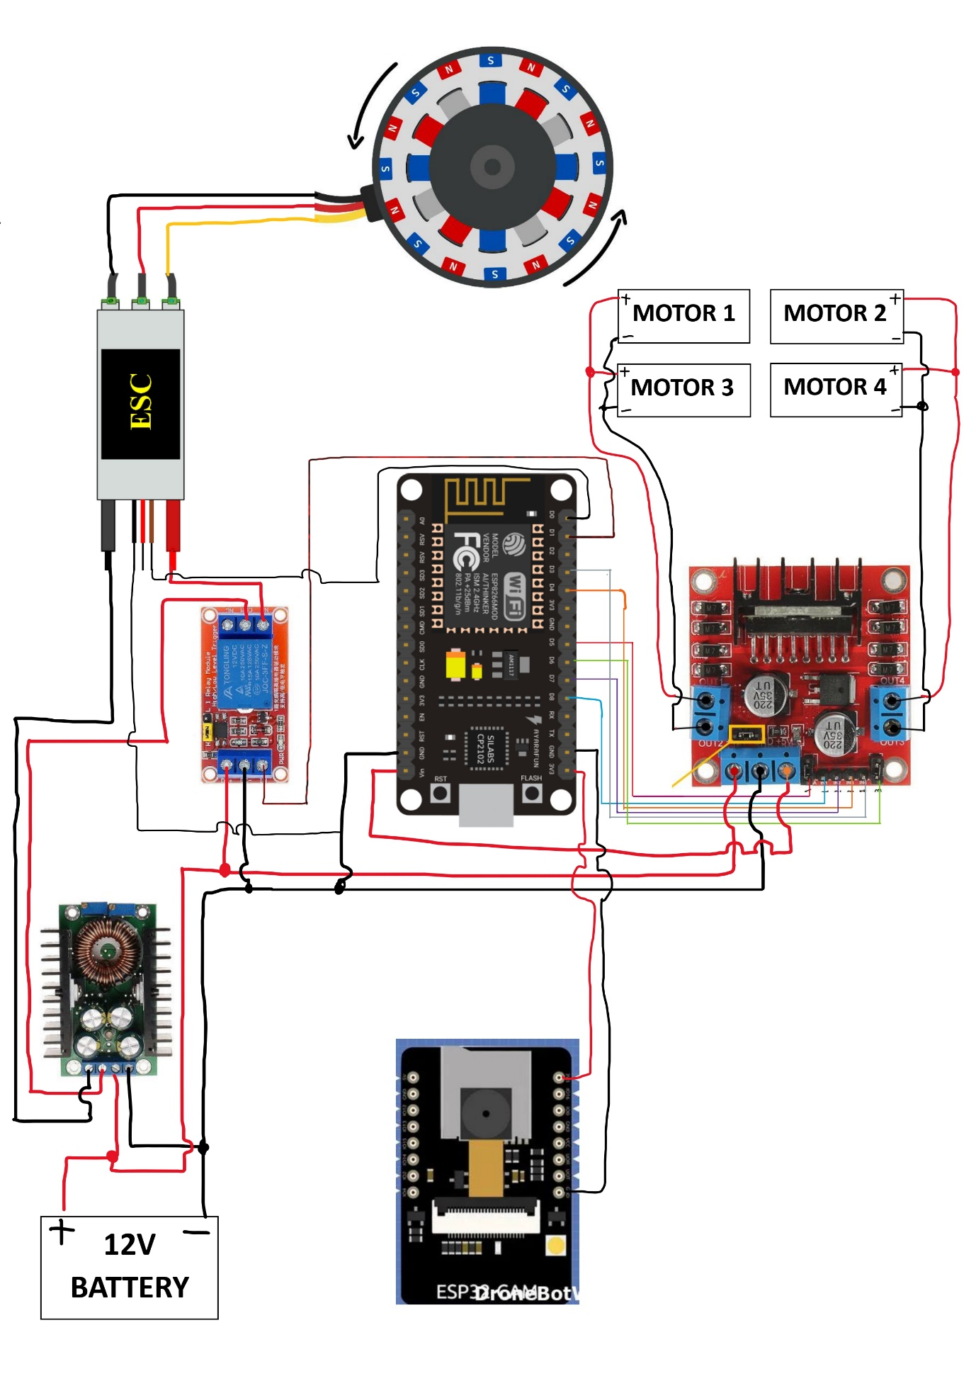**Circuit Connections:**

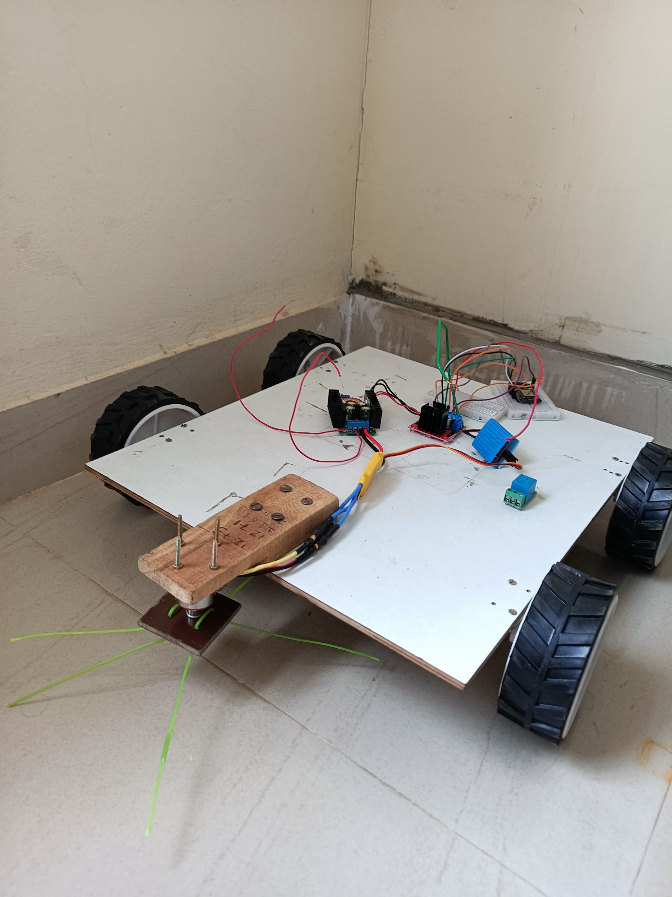**Prototype Model:**

**Problems we faced:**

We have observed that the area of cutting grass is less that what we assumed and size of the machines is also heavy.

We need to do some calculations on gear motors, controller and NodeMCU to improve efficiency.

We have observed some difference and wrong in arrangement in wheels where it leads to improper movement on the machine.

There is disconnection of Wi-Fi from NodeMCU and heating issues in Motor Controller due to high current consumption.

As we are using metal gear motor instead of BO gear motors, if load increases or anything got stocked it leads to mis-connection of gears.

**Summary:**

To summarize this project, given the challenges we've encountered, we need to revisit the calculations related to the equipment used to ensure it provides the required voltage source to achieve our objectives.